Network Simulation
Topic: OSI Model, TCP/IP Model & Wireshark Packet Analysis

Submitted By -
Sahil.mk
24ubc162
II Bca (A)

Part -A
OSI Model Theory

1. OSI Layer Explanations
Layer 1 – Physical
The Physical layer is responsible for the actual transmission of raw bits over a communication medium. It deals with cables, signals, voltages, frequencies, connectors, and data rates. This layer doesn’t understand data; it only moves 0s and 1s as electrical, optical, or radio signals. A real-world analogy is the road in a transportation system—the road doesn’t care what vehicle is traveling; it only provides the physical path. Examples include Ethernet cables, Wi-Fi radio signals, USB, fiber optics, hubs, and repeaters.

Layer 2 – Data Link
The Data Link layer ensures reliable communication between devices on the same network (same LAN). It organizes bits from Layer 1 into frames, manages MAC addresses, error detection, and controls who can use the network at a given time. It also prevents collisions in shared networks. A real-world analogy is traffic rules on a road (like who moves first). Examples include Ethernet, Wi-Fi (IEEE 802.11), MAC addressing, ARP, and switches.

Layer 3 – Network
The Network layer is responsible for logical addressing and routing. It decides the best path for data to move across multiple networks (internetworks). It uses IP addresses to identify devices and forwards packets based on routing tables. It’s like a GPS system that decides the best route to reach a destination. Key protocols include IP (IPv4/IPv6), ICMP, ARP, NAT, and routers.

Layer 4 – Transport
The Transport layer provides end-to-end communication and ensures reliable or fast delivery depending on the protocol. TCP provides reliability, ordering, and error recovery, while UDP focuses on speed without reliability. It also uses port numbers to identify applications. A real-world analogy is a courier service that tracks packages (TCP) or a fast-food delivery boy who drops off quickly without confirmation (UDP). Examples: TCP, UDP.

Layer 5 – Session
The Session layer manages the opening, closing, and maintaining of communication sessions between devices. It keeps track of dialogues, checkpoints, and synchronization. It’s like a phone call connection where the call needs to be started, maintained, and ended. Protocol examples: NetBIOS, RPC, and APIs involved in session handling.

Layer 6 – Presentation
The Presentation layer focuses on data translation, encryption, and compression. It ensures that data sent by one system can be understood by another. It’s like a translator converting a document into a language both parties understand. Examples include SSL/TLS encryption, JPEG, MP3, and character encoding formats like ASCII/Unicode.

Layer 7 – Application
The Application layer is where users interact with network services. It includes all the services and protocols that applications use to communicate over the network. It doesn’t mean "apps" but the interface between the OS and network services. A good analogy is a waiter who interacts with customers and takes their orders. Examples: HTTP, HTTPS, DNS, FTP, SMTP, SSH.

2. OSI Mnemonic
My mnemonic:
“Please Do Not Throw Sausage Pizza Away”
- P – Physical
- D – Data Link
- N – Network
- T – Transport
- S – Session
- P – Presentation
- A – Application
This mnemonic helps remember the 7 OSI layers from bottom Layer 1 to top Layer 7.

3. OSI vs TCP/IP Model Comparison
The OSI model is a theoretical 7-layer model used for teaching and understanding network communication. The TCP/IP model is a practical 4-layer model used in real-world networking and the internet. OSI separates responsibilities more clearly (especially Session and Presentation layers), while TCP/IP combines them for simplicity and performance. OSI is descriptive, while TCP/IP is implementation-based.
Mapping Table
Osi Layer | TCP/IP Layer
Application / Presentation / Session (L7/L6/L5) | Application
Transport (L4) | Transport
Network (L3) | Internet
Data Link / Physical (L2/L1) | Network Access

4. Protocol Data Units (PDUs)
Osi Layer | PDU Name
Layer 4 - Transport | Segment (TCP) / Datagram (UDP)
Layer 3 - Network | Packet
Layer 2 - Data Link | Frame
Layer 1 - Physical | Bits

5. Addressing Concepts
MAC Address – Layer 2
A MAC (Media Access Control) address is a hardware address burned into a network interface card. It uniquely identifies a device inside a LAN. It is used by switches to forward frames. Format example: 00:1A:7D:9F:3C:10.

IP Address – Layer 3
An IP address is a logical address used to identify devices across different networks. Routers use IP addresses to forward packets across the internet. Example: 192.168.1.10 or 2405:204:... (IPv6).

Port Number – Layer 4
Port numbers identify which application or process should receive the data on a device. For example, port 80 is HTTP and port 443 is HTTPS. TCP/UDP use port numbers to manage many applications using the network at the same time.

Part -B
Wireshark Practical

1. HTTP Traffic (Application over TCP)

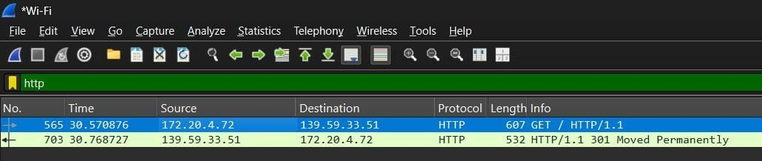
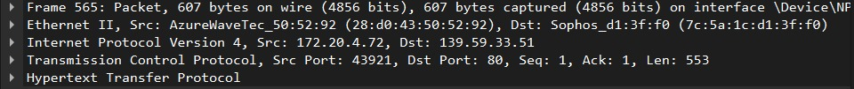

2. TCP Packets

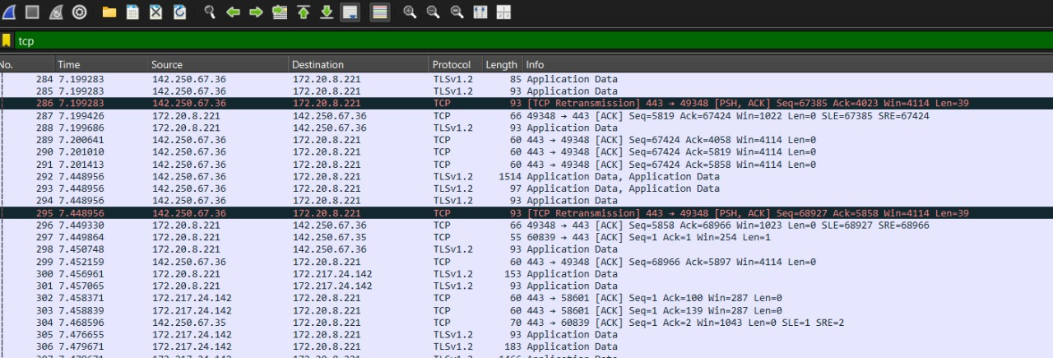
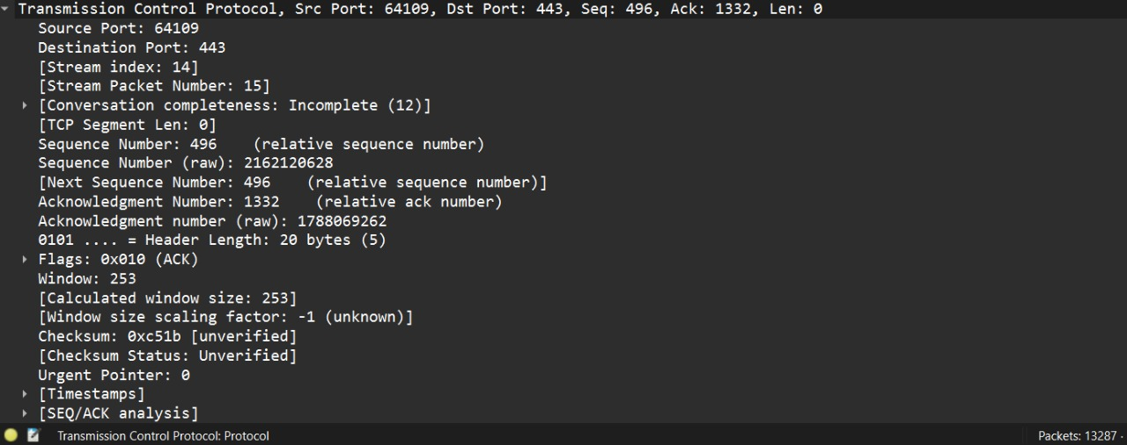
3. UPD Packets

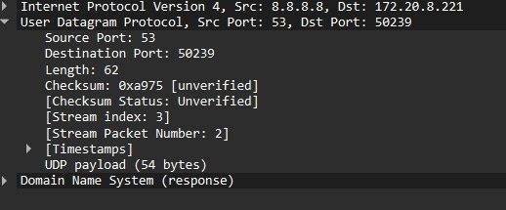
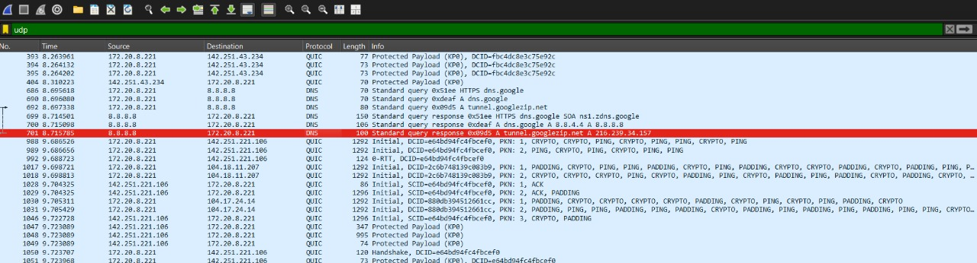

4. ICMP Packets (ping)
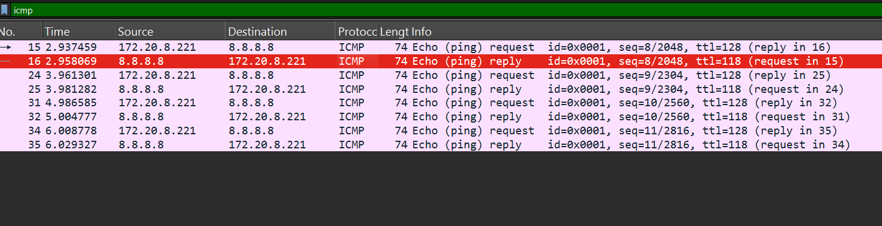
Request Message
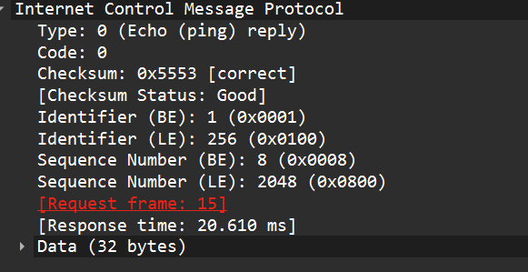
Reply Message

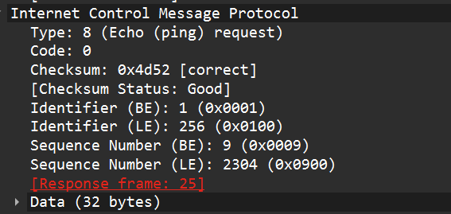

5.APR Frames
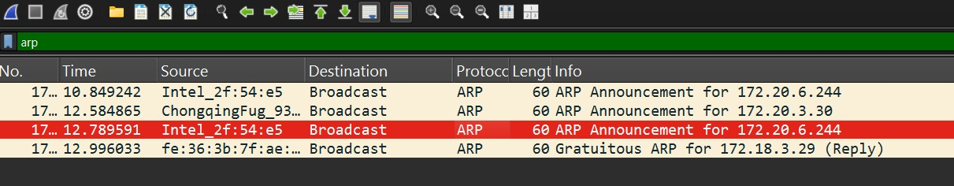

Reply Message

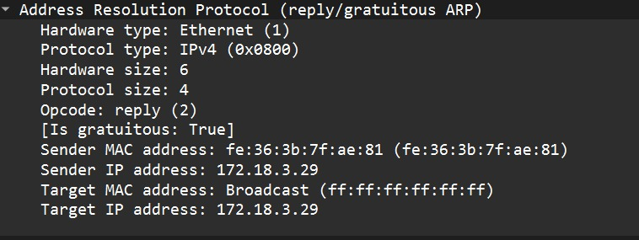
Request Message

